Early years and childcare
Purpose

Members are asked to consider:
- funding for early years and childcare
- the role of councils in improving availability of early years provision
- the role of councils in improving quality in early years’ provision.

Summary

This report provides an overview of early education and childcare policy and funding and seeks direction from the Board for the key issues raised in the report.

Ellen Broome, Director of Policy, Communication and Research at the Family and Childcare Trust (FCT) will attend the meeting to discuss the FCT’s views on the need for a review of childcare funding.

Recommendations

Members are asked to consider and provide a steer on LGA’s work on early years and childcare in order to build the case for devolving more decision making to a local level.

Actions

Officers to take action arising out of discussion, as directed by members.

Contact officer: | Liz Hobson
Position: | Senior Adviser
Phone no: | 0207 664 3229
Email: | liz.hobson@local.gov.uk

Early years and childcare

Background
- Early education and childcare is expected to feature strongly in the General Election manifestos for all of the main political parties. This is driven in part by the importance of early education in narrowing gaps in attainment, especially for children from disadvantaged backgrounds, and partly by the needs of working parents for affordable childcare.

- The LGA has given evidence to the Education Select Committee’s inquiry into Children’s Centres and to the House of Lords Affordable Childcare Select Committee, setting out our concerns about the need for early years services to be determined locally and calling for a review of the early years funding system with the aim of reducing the complexity caused by the different funding sources. The reports from both select committees reflect our concerns about the need for more coherent thinking on early years’ funding policy. The Association of Directors of Children’s Services (ADCS) in its recent Early Years Policy Position paper suggests that help with childcare should be targeted on the most vulnerable children and that there should be investment in parenting and wider family support alongside the free childcare offer.

- A number of initiatives are underway in councils, including Croydon’s ‘ Best Start’ which is aiming to bring together key services including health visiting, children’s centres, early years and the voluntary sector into an integrated service model. Lambeth and Southwark have just published a joint Childcare Commission report which calls on the Government to bring together early years and education funding, taking a 0 –18 approach.

- Other reports also call for the next government to carry out a fundamental review of childcare funding, including the Family and Childcare Trust’s (FCT) annual survey of childcare costs. The FCT’s survey shows a steep rise in nursery costs for the under 2s, and the FCT also suggests that there is a need for councils to do more to support the childcare needs of families because of growing gaps in provision.

Complexities in the funding system

- There are a range of subsidies and different funding systems for early years services, run by at least five different Government departments, and at times there can be tensions between what different policies are trying to achieve, as well as inefficiencies and poor targeting around need for different families in different places.

- The Government currently invests £5.2 billion annually in early education and childcare, with just over half (56%) spent on the early education entitlement allocated through the Dedicated Schools Grant. Spending is set to rise to £6.4 billion in the next Parliament with the implementation of the tax-free childcare scheme for working parents and the childcare element of the roll-out of Universal Credit.

- The hourly rate in cash terms for early education for 3 and 4 year-olds for 15 hours a week, 38 weeks a year, has been frozen for the last three years. Providers in the Private Voluntary and Independent (PVI) sector (who provide around 60% of places for 3 year olds) have complained that there is a significant shortfall in funding for the free entitlement. The funding is allocated to councils on a historic basis, with a wide disparity in funding levels across the country, which also impacts on childcare costs for parents over and above the free entitlement. There is already a national formula for the funding of the offer for disadvantaged 2 year olds but there are still issues concerning willingness of larger PVI providers to provide places and some big differences in levels of take-up within and between different council areas.

- Early education funding cannot be used flexibly, and it is not always well linked to needs of the children and parents whom it is intended to benefit. For example, the funding cannot be used by parents for ‘portage’ services to provide home learning support for young disabled children. Evaluations of the 2 year old pilots found that in some areas, provision that was effective in improving outcomes for children required a combination of childcare and parenting support. However, this learning has not been incorporated into the offer, which is delivered largely by providers without this support.

- There are a number of other Department of Education (DfE) funding streams, including £50 million for the introduction of the Early Years Pupil Premium from April 2015, which is targeted at disadvantaged 3 and 4 year olds, but with slightly different eligibility rules from the free entitlement for disadvantaged 2 year olds. There is separate funding for pilot schemes such as the Social Investment Pilot to encourage PVI providers into deprived areas and for Teaching Schools to work with the PVI sector.

- Children’s Centres are funded through general funding from council tax, retained business rates and revenue support grant, not through DfE grants. Funding for the 0 – 5 public health duties is provided in a ring-fenced grant from the Department of Health.

- Schools have been protected from the cuts councils have faced, but DfE regulations governing the Schools Budget prevent Schools Forums from further pooling resources with councils to provide integrated early help services, even though schools have a shared interest in ensuring that young children are ‘school-ready’.

- From October 2015, when the government introduces the tax-free childcare scheme for working parents, three different subsidy regimes for working families’ spending on childcare, over and above the free entitlement, will be in place through the tax and benefits system, with different eligibility rules, and different levels of support that are not simple to navigate or understand.

- The Family and Childcare Trust, among others, have argued for parents to be able to move more easily between the new tax free childcare scheme and universal credit. The House of Lords affordable childcare report recommended that the Government should consider a single mechanism for childcare subsidies to support working parents.

- The LGA has called for an overhaul of early years funding, to remove the unnecessary complexity in the system and provide a streamlined and place-based approach that devolves decision making to a local level. The chart attached at Appendix 1 demonstrates the amount of estimated annual spending that is expected to be in place for the under-5s during the next Parliament, including the forthcoming changes to the childcare subsidies for working parents through the tax-free childcare scheme and the introduction of Universal Credit.

Improving availability in deprived areas

- There has been a rapid expansion in the overall scale of early years’ provision, but there are significant variations in availability between local areas. Evidence shows that participation remains lower for disadvantaged groups, even though research shows that they have the most to gain from early education and childcare. At the same time, the role of councils in tackling the availability and quality of early years’ education and childcare is now much more restricted than it was previously.

- Explicit limits are placed on the role of councils in childcare provision by the Childcare Act 2006. Councils should not provide places directly, unless there are no other providers that are willing to do so. The growth in early years’ education and childcare over the last ten years has been almost entirely in the PVI sector and there has been little expansion in public sector provision. There is also strong evidence that the overall quality of provision is lower among PVI providers than in the public sector, particularly in disadvantaged areas.

- DfE survey figures show that in 2013 only around one in ten childcare places were run by either councils or schools but two-thirds of full day care settings in children’s centres were maintained and half of these were run by councils directly.

- The Government is keen to encourage schools to expand nursery provision and there have been a number of recent Government initiatives to address poor availability of early years and childcare provision in some disadvantaged areas. These include pilot schemes to attract social investment and to encourage Teaching Schools to work with PVI providers. Councils are widely viewed as ‘providers of last resort’ and there has been very little incentive - or funding - for councils to take the initiative in increasing public sector provision in deprived areas, where parents find it difficult to pay market rates for private childcare provision over and above the free entitlement.

- Councils have also faced criticism for failing to ensure that there is sufficient childcare for working parents beyond the free entitlement (and for school age children up to the age of 14), even though the law recognises that it may not be practicable for a council to secure childcare to meet the requirements of every parent in their area because of funding constraints.

- Rather than Whitehall trying to tackle the issue of lack of availability of childcare in deprived areas, councils could be given more freedom and flexibility to determine what is needed and to target help with childcare for the under-5s on vulnerable children and families.

- Councils already play a significant role in providing support for low income households to move out of poverty and tackle the range of barriers they face in finding work. The LGA through its work on employment and skills overseen by the People and Places and Cities and Regions Boards has been challenging inflexible and fragmented national schemes and restrictions. The restrictions on the role of councils in childcare provision can also get in the way of providing effective support to the most disadvantaged families.

Improving quality in deprived areas

- There is good evidence that high quality early education improves outcomes for children, particularly for disadvantaged children who may not have a positive home learning environment. The Early Years Foundation Stage (EYFS) which must be followed by all schools and Ofsted registered providers, including child-minders, sets standards for the learning, development and care of children from birth to 5 years.

- According to a recent Nuffield Foundation report on lessons from evidence of early years education, the maintained sector continues to be the most effective in terms of learning outcomes. This underlines the role of staff qualifications in raising quality, with the presence of a teacher with graduate-level qualifications identified as particularly important. Maintained schools in disadvantaged areas also offer comparable quality to those serving more advantaged areas. But across the PVI sector, quality has been found to be lower in settings in deprived areas serving disadvantaged children

- Ofsted are now the ‘sole arbiters of quality’ in early years’ provision in 25,000 nurseries and pre-schools, 54,000 childminders and in 16,000 primary schools with nursery classes and over 400 maintained nursery schools. Councils must base decisions about funding the free entitlement on the provider’s Ofsted inspection judgement. Councils cannot require providers with an Ofsted judgement of ‘good’ or better to undertake any training or quality improvement, even though there can be four years between inspections.

- Councils previously played a key role in providing on-going support for all early years’ settings and research shows that a wide range of quality measures is valuable in helping to understand what is happening in early years’ settings. Relying on Ofsted’s single judgement may be too blunt to use as a basis for decisions about funding the free entitlement and further support. We have called into question the wisdom of just leaving good or outstanding schools alone until any problems become serious and the same applies to early years’ settings. Allowing councils the flexibility to provide support for early years providers across the spectrum, in the same way that they support school improvement, might also help to improve links and co-ordination between early years’ education and primary schooling.

Recommendations

- Members are asked to consider and provide a steer on LGA’s work on early years and childcare in order to build the case for devolving more decision making to a local level.

Financial Implications
- There are no additional financial implications for the LGA arising from the report.

Appendix A

Estimated annual public spending on the early years in the next Parliament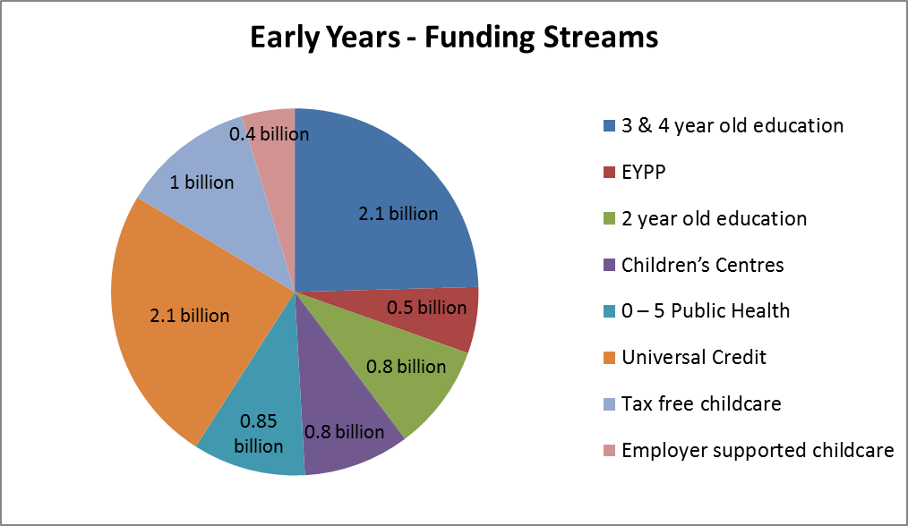
Source:DfE written evidence to House of Lords and Childcare Payments Bill Revised Impact Assessment, November 2014, House of Commons Education Select Committee report on Children’s Centres 2013

Funding for provision
The largest amount of early years funding is for the early education entitlement through the Dedicated Schools Grant, (DSG): £3.1 billion for 3 and 4 year olds and £0.8 billion for 40% of 2 year olds who are disadvantaged. £50 million has been provided to fund the Early Years Pupil Premium for disadvantaged 3 and 4 year olds from April 2015.

Significant funding is also allocated annually by councils to children’s centres which is estimated at £0.8 billion. In April 2011 the Government removed the ring-fence from Children’s Centre funding and introduced the Early Intervention Grant (EIG). From April 2013, EIG was transferred to the Department for Communities and Local Government to include in its Business Rates Retention scheme.

Childcare subsidies for parents
The Government proposes to increase the level of childcare help in the new Universal Credit (UC) in April 2016 to 85 per cent of childcare costs, up from the 70 per cent that is presently available through Working Tax Credit, up to a maximum cost of £175 per week for one child.

Later in 2015, employer-supported vouchers will begin to be phased out and replaced by a tax-free childcare scheme. For every 80p that parents will pay into a childcare account, the Government will pay in 20p, up to £2,000 support per child per year. The scheme will be available for those earning up to £150K a year but those on UC will not be eligible. The scheme will be introduced initially for childcare for the under-5s.

